Guidelines for the completion of the School information request for the

Annual Faculty Quality Report (AFQR)

Context
The Annual Faculty Quality Report (AFQR) was introduced in 2013/14 in response to recommendations from the Institutional Quality Review of Trinity College in 2012. Since then, the AFQRs have become embedded in the annual cycle of monitoring of the enhancement of education and related risks to the quality of education and the student experience in Trinity.

The information request completed by Schools informs the development of an AFQR by each of the three Faculties. The template for the information request has evolved, at the request of the Faculties, to include commentary on internal and external factors that impact the quality of education provision e.g. Staff- Student Ratios, staff vacancies, new strategic initiatives (such as TEP) and the Covid -19 pandemic, all of which present challenges to how we ensure the maintenance of quality, academic standards and the student experience. The information request is reviewed annually to ensure it remains pertinent to the current context. As such, the report is a mechanism to close the feedback loop to College on local implementation issues, responses to new policies etc. The Annual Faculty Quality Reports are considered by the Quality Committee in March/April each year, and a summary (consolidated) report is presented to Council for approval, with the three reports attached as appendices (see Fig 1).

The purpose of the Annual Faculty Quality Report is:
- to optimise the use of available sources of quality performance data by Schools and Faculties to respond to quality and accreditation review processes and demonstrate a Plan-Do-Check-Act cycle in the consideration of quality performance data such as the National Student Survey, International Student Barometer and External Examiner reports. Since 2018/19, this reporting has been through School Action Plans that form part of the report.
- to inform School and Faculty decision-making in respect of shared good practice and provide a means to escalate system-wide issues that act as a constraint to quality.
- to facilitate annual reporting through the Annual Quality Report to QQI on compliance areas under the Act which serves as an input to the institutional review.
- to facilitate monitoring of and reporting on the implementation of Council decisions in respect of undergraduate module (CL/12-13/148); postgraduate surveys (CL/11-12/172) and recording of external examiner recommendations at Courts of Examiners (CL/14-15/083).
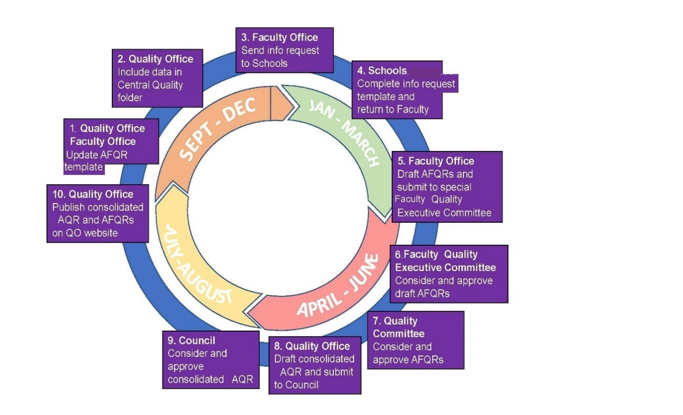

Fig 1: The process for development of the Annual Faculty Quality Reports

TERMS OF REFERENCE

All components of the School information request must be completed/responded too.

Attention should be given to the following:

the consistency and accuracy of numeric data provided, as this information is presented to Council in the Consolidated Annual Quality Report.

the balance between description and analysis - where possible, quantifiable measures of impact should be provided.

clarity on what is within the remit of Schools and/or is considered the remit of College.

a professional tone should be maintained in the language used in the report, as per the College Dignity & Respect Policy, as the report will be available in the public domain.

The Head of School is required to sign-off on the School’s response to the Information Request Form.

School Action Plans should be monitored at School Executive Meetings throughout the year to ensure that action on School commitments is progressed.

Quality should be a standing item on Faculty Executive Meetings and each Faculty is required to have an annual dedicated Faculty Quality Executive Meeting to discuss and approve the Annual Faculty Quality Report.

Faculty Deans will consult on issues to be escalated to Academic Council from across all three Annual Faculty Quality Reports.

Table 1: Draft Timeline for the 2020/21 Annual Faculty Quality Report (AFQR)

Year 1- 2020/21 | Academic Year that is the subject of the report – 2020/21 |  | Action
Year 2 - 2021/22 | November 2021 | National Student Survey Reports for 20/21 disseminated to Schools | Quality Office
 | November 2021 | All 20/21 UG External Examiner Reports expected to be returned. | Schools  Quality Office
 | December 2021 | All 20/21 PGT External Examiner Reports expected to be returned. | Schools  Deanssec@tcd.ie
 | 24 January 2022 | AFQR Information Request sent to Schools – new AY structure. | Faculty Administrator
 | 14 February 2022 | Response due back from Schools on information request. | Schools
 | XXX 2022 | Progression and Retention data available. | Faculty Administrators/  AR
 | 7 March 2022 | Draft 1 of AFQR complete. | Faculty Administrators
 | Wk b/g 14 March 2022 | Annual Faculty Quality Executive Meetings. | Faculty Dean  Faculty Administrators
 | Wk b/g 4 April 2022 | Draft Annual Faculty Quality Report due to Quality Office | Faculty Administrators.
 | 7 April 2022 | Final AFQR due to Quality Office for QC circulation | Faculty Administrators
 | 14 April 2022 | All three Annual Faculty Quality Reports presented at Quality Committee | Faculty Dean.  Quality Office.
 | Late April/Early May 2022 | Meeting with Faculty Deans to consider escalated issues to Council in the Consolidated Quality Report. | Faculty Deans  Quality Office
 | June 2022 | Consolidated Report and individual Annual Faculty Quality Reports (AFQR) considered by Council | VP-CAO

Table 2: Sources of data to help Schools complete the Information request.

Source | Year | Location | Contact
UG External Examiners Reports | 2020/21 | Central Quality Storage | Amy Murray Quality Office
PGT External Examiners Reports | 2020/21 | Central Quality Storage | Deanssec@tcd.ie
National Student Survey.ie Report (College) | 2020/21 | Central Quality Storage | Amy Murray  Quality Office
National Student Survey.ie report (School) | 2020/21 | Central Quality Storage | Amy Murray  Quality Office
Quality Review Summary (to include reviews, Implementation plans and progress reports) | current  update | Quality Office | Liz Donnellan  Quality Office
Accreditation reports | Last available | Schools/Disciplines | School Administrative Manager
Progression and Retention data | Entry in 20/21 and progressing to 21/22 | Academic Registry | Faculty Admin/Academic Registry

Table 3: Quantitative Data to inform Faculty Performance on key metrics for Annual Faculty Quality Report.
[Ensure numbers reported are verified via sources above prior to submission]

Table 1: UG student module evaluation – Science, Technology, Engineering and Science (STEM)
School | Number of Undergraduate Modules taught | Number of Undergraduate  Modules Evaluated | Percentage of Undergraduate Modules Evaluated | Average response rate to UG module evaluations (%) | Comments/Actions arising Evaluations
Biochemistry & Immunology
Chemistry
Computer Science and Statistics
Engineering
Genetics and Microbiology
Mathematics
Natural Sciences
Physics
Faculty Total

Table 2: Open Module Evaluation – Science, Technology, Engineering and Science (STEM)
School | Title of Open Module(s) offered, in full | Actual response rate to Open Module evaluations using USC approved survey questions (%) | Comment/Actions arising from Evaluations
Biochemistry & Immunology
Chemistry
Computer Science and Statistics
Engineering
Genetics and Microbiology
Mathematics
Natural Sciences
Physics
Faculty Total

Table 3: Undergraduate External Examiner Reports - Science, Technology, Engineering and Science (STEM)
School | No of External Examiner Reports Expected (UG) | No of External Examiner Reports Returned (UG) | % of External Examiner Reports Returned (UG) | Did the School respond in writing to EE recommendations? | Did the External Examiner(s) have or request access to Blackboard? | Comment/Actions arising from EE Reports
Biochemistry & Immunology |  |  |  | Yes ☐No☐ | Yes ☐ No☐
Chemistry |  |  |  | Yes ☐No☐ | Yes ☐ No☐
Computer Science and Statistics |  |  |  | Yes ☐No☐ | Yes ☐ No☐
Engineering |  |  |  | Yes ☐No☐ | Yes ☐ No☐
Genetics and Microbiology |  |  |  | Yes ☐No☐ | Yes ☐No☐
Mathematics |  |  |  | Yes ☐No☐ | Yes ☐No☐
Natural Sciences |  |  |  | Yes ☐No☐ | Yes ☐No☐
Faculty Total

Table 4: Postgraduate Module Evaluation - Science, Technology, Engineering and Science (STEM)
School | No. of PGT Programmes | No. of PGT Programmes Evaluated | % of PGT Programmes Evaluated | Average response rate to PGT programme evaluations (%) | Comment/Actions arising from EE Reports
Biochemistry & Immunology
Chemistry
Computer Science and Statistics
Engineering
Genetics and Microbiology
Mathematics
Natural Sciences
Faculty Total

Table 5: Postgraduate External Examiner Reports - Science, Technology, Engineering and Science (STEM)
School | No of External Examiner Reports Expected (PG) | No of External Examiner Reports Returned (PG) | % of External Examiner Reports Returned (PG) | Comment/Actions arising from EE Reports
Biochemistry & Immunology
Chemistry
Computer Science and Statistics
Engineering
Genetics and Microbiology
Mathematics
Natural Sciences
Faculty Total

Table 6: Professional Accreditation – Science, Technology, Engineering and Science (STEM) (please update/amend where appropriate)

SCHOOL | ACCREDITED PROGRAMME | PROFESSIONAL OR STATUTORY BODY | NEXT ACCREDITATION DUE | DID ACCREDITATION TAKE PLACE IN 2020/21? IF SO, SPECIFY WHETHER IN PERSON OR VIRTUALLY | Comment if any conditions resulted from Accreditation Report outcomes e.g. reduced period of accreditation
School of Engineering | B.A.I/M.A.I. - Civil, Structural & Environmental Engineering | Engineers Ireland | 5 years  Re-accreditation in Nov/Dec. 2020 postponed (due to Covid-19). Rescheduled to March 2022.
 | B.A.I./M.A.I. - Computer Engineering
School of Engineering | B.A.I./M.A.I. - Electronic Engineering | Engineers Ireland | 5 years  Re-accreditation in Nov/Dec. 2020 postponed (due to Covid-19). Rescheduled to March 2022.
 | B.A.I./M.A.I. - Electronic & Computer Engineering
 | B.A.I./M.A.I. - Mechanical & Manufacturing Engineering
 | B.A.I./M.A.I. Biomedical Engineering
 | B.Sc. (Ing) / M.A.I. (optional) Engineering with Management
 | MSc in Engineering (Civil)
 | MSc in Mechanical Engineering
School of Physics | B.A. (Moderatorship) in Physics | Institute of Physics (IoP) | Due March 2021 but postponed due to Covid-19. Provisional date November 2021
 | B.A. (Moderatorship) in Physics & Astrophysics | Institute of Physics (IoP) | Due March 2021 but postponed due to Covid-19. Provisional date November 2021
B.A. (Moderatorship) in Theoretical Physics (joint programme with School of Mathematics)

B.A. (Moderatorship) in Nanoscience (joint programme with School of Chemistry)

Please outline here three quality initiatives undertaken by the School in 2020/21 that you wish to showcase as good practice/enhancement activities.
Please outline any quality issues that fall outside the remit of the School for escalation to Faculty or College-level

Statement of Assurance by Head of School:
Note: Completion of this statement is required by the Audit Committee

To the best of my knowledge College’s academic policies and quality procedures are followed in the operation of areas under my remit. I confirm that due care has been taken to ensure the veracity of data contained in this report.

Head of School:

Date:

